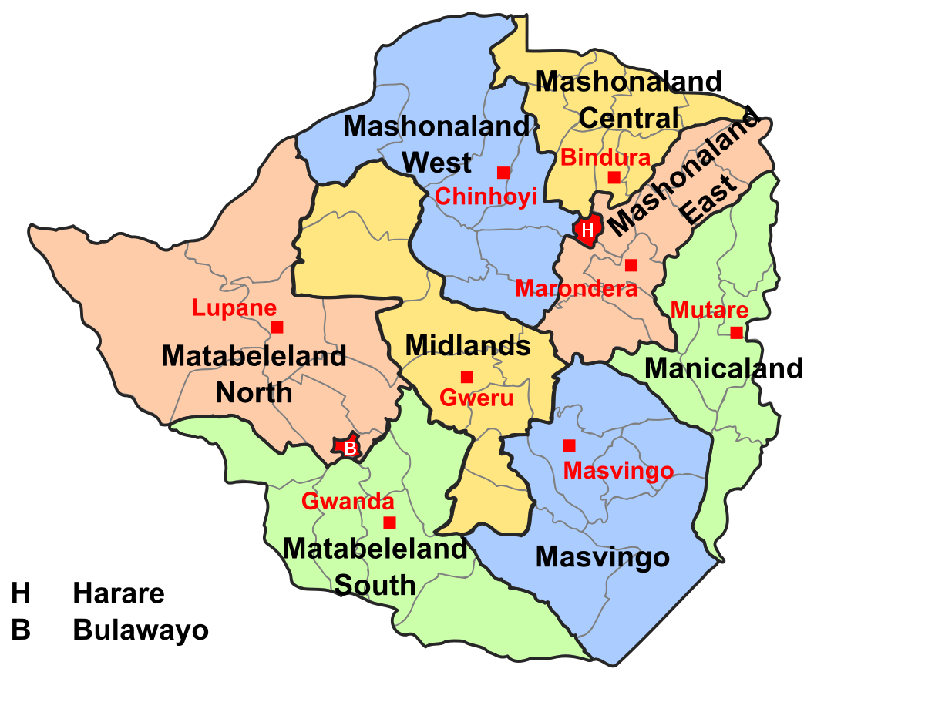 27 January 2021
Blended consumer Price Index (JULY 2020 = 100) – JANUARY 2021

The month on month inflation rate in January 2021 was 2.76 percent gaining 0.01 percentage points on the December 2020 rate of 2.75 percent. (See note on period of data collection below).

This means that prices as measured by the all items blended CPI increased by an average rate of 2.76 percent from December 2020 to January 2021.

The month-on-month inflation rate is given by the percentage change in the index of the relevant month of the current year compared with the index of the previous month in the current year.

The month on month Food and Non Alcoholic Beverages inflation rate stood at 4.11 percent in January 2021, shedding 0.43 percentage points on the December 2020 rate of 4.54 percent. The month on month non-food inflation rate stood at 2.13 percent, gaining 0.20 percentage points on the December 2020 rate of 1.93 percent.

The blended CPI for the month ending January 2021 stood at 110.52 compared to 107.55 in December 2020 and 37.91 in January 2020.

The year on year inflation rate (annual percentage change) for the month of January 2021 as measured by the all items blended Consumer Price Index (CPI) stood at 191.52 percent.

This means that prices as measured by the all items blended CPI increased by an average of 191.52 percent between January 2020 and January 2021.

The year-on-year inflation rate is given by the percentage change in the index of the relevant month of the current year compared with the index of the same month in the previous year.
- Period of Data Collection

It is important to note that data on prices was collected during the period from 13 to 19 January 2021. The changes in prices in this report refer to that period of data collection.

The Methodology

With effect from June 2020 ZIMSTAT is publishing the new Consumer Price Index (CPI) code named Blended Consumer Price Index. It measure the combined price changes of goods and services in both the USD and ZWL.

Two separate indices were computed, that is, the USD Consumer Price Index and the already available ZWL Consumer Price Index. The original CPI weights were splitted into USD and ZWL components using linking factors. These linking factors were the proportions of estimated household expenditure in USD and ZWL according to the COICOP classification. The resultant weights were then used to combine the two indices to come out with the blended index.

Contact us
Tel: 706681/7
E-mail: prices@zimstat.co.zw

Mean Month on Month Rates

The mean month on month inflation rate for the period January to December 2020 was 9.6 percent. The month on month inflation rate for the month of January 2021 was 2.76.

Rebasing of Blended Consumer Price Index
From August 2020 onwards, the blended CPI was rebased to July 2020 = 100. This was caused by the revision of the linking weights between the United States Dollar CPI and the ZWL CPI

For users who wish to continue with the old index reference period of June 2019 = 100, they should multiply the new All Items Index with the factor 6.49960354088181

Table 1: Month on month inflation rate from December 2019 to December 2020
Month | Dec-19 | Jan-20 | Feb-20 | Mar-20 | Apr-20 | May-20 | Jun-20 | Jul-20 | Aug-20 | Sep-20 | Oct-20 | Nov-20 | Dec-20
Month on Month Inflation rate | 12.0 | 1.8 | 11.7 | 19.6 | 15.3 | 13.5 | 29.4 | 16.7 | 1.4 | -0.5 | 1.4 | 2.2 | 2.8

Figure 1: Month on month inflation rate from December 2019 to December 2020

